

International School

Capstone Project 2
CMU-SE 450

User Story
Version 1.0
Date: December 12th, 2025

SEIMS - Smart Expiry Product Integration & Management System

Created by C2SE.15
Pham Minh Trang - 28204632177
Nguyen Pham Nhat Huy - 28211100686
Nguyen Huu Thang - 28211102537
Duong Quoc Binh - 28219006390
Nguyen Huy Hoang Bao - 28219004148

User Story Review Panel Representative:

Name Signature Date
Capstone Project 2 - Mentor:

Name MSc.Truong Dinh Huy Signature Date
PROJECT INFORMATION

Project acronym | SEIMS
Project Title | Smart Expiry Product Integration & Management System
Start Date | February 30, 2026 | End Date |  | April 30, 2026
Lead Institution | International School, Duy Tan University
Project Mentor | MSc.Truong Dinh Huy  Email: huy.truongdinh@gmail.com  Tel: 0982132352
Scrum master / Project Leader & contact details | Pham Minh Trang  Email: pmtrang04@gmail.com  Tel: 0911855450
Partner Organization | Duy Tan University
Team members | Name |  | Email |  | Tel
28204632177 | Pham Minh Trang |  | pmtrang04@gmail.com |  | 0911855450
28211100686 | Nguyen Pham Nhat Huy |  | huy785619@gmail.com |  | 0395546300
28211102537 | Nguyen Huu Thang |  | nguyenhuuthang11@dtu.edu.vn |  | 0702377702
28219006390 | Duong Quoc Binh |  | duongquocbinh@dtu.edu.vn |  | 0932033856
28219004148 | Nguyen Huy Hoang Bao |  | bao91ndu1819@gmail.com |  | 0385092839

DOCUMENT APPROVALS
The following signatures are required for approval of this document.
MSc.Truong Dinh Huy  Mentor | Signature | Date
Pham Minh Trang  Student ID: 28204632177  Project Leader | Signature | Date
Nguyen Pham Nhat Huy  Student ID: 28211100686  Team Member | Signature | Date
Nguyen Huu Thang  Student ID: 28211102537  Team Member | Signature | Date
Duong Quoc Binh  Student ID: 28219006390  Team Member | Signature | Date
Nguyen Huy Hoang Bao  Student ID: 28219004148  Team Member | Signature | Date

DOCUMENT NAME
Document Title | User Story
Author(s) | Nguyen Huy Hoang Bao
Role | Team Member
Date | March 12, 2026 | File name: | 4 C2SE.15_UserStory_Ver1.0.doc

REVISION HISTORY
Version | Date | Comments | Author | Approval
1.0 | March 14, 2026 | Create Document | Bao

Table of Contents
1. Introduction 1
1.1. Document Overview 1
1.2. Business values 2
2. Use Case of “Coffee Leaf Disease Detection System“ 3
3. User Stories 4
3.1. Admin 4
3.2. Farmer 5
3.2. Development team 8
4. Table User Stories Priority 9

1. Introduction
In the field of software development, User Stories are widely used in Agile methodology to describe the needs of end-users in a natural, non-technical language. They capture the “who”, “what”, and “why” of a requirement in a concise way, making them easy to understand and prioritize. By working closely with users to create user stories, the development team can better understand the required functionality and ensure the system meets real-world needs.
In this application, the main purpose is to support supermarkets and retail chains in managing near-expiry products efficiently. The system enables users such as system administrators, supermarket managers, store staff, customers, and charity organizations to monitor product expiry dates, apply discount policies, manage donation processes, and access near-expiry products through a centralized platform.
User stories will describe key features such as inventory lot management, near-expiry detection, automated discount calculation, donation workflow (B2B), product browsing and ordering with in-store pickup (B2C), notification system, and dashboard reporting. In addition, non-functional requirements such as system security, performance, usability, and data integrity are also considered to ensure the system operates reliably and efficiently.

1.1. Document Overview
This document provides a user story and goal-oriented view of the SEIMS – Smart Expiry Product Integration & Management System project. It highlights several key benefits:
- It answers the question: “What does this project do?” for users including system administrators, supermarket managers, store staff, customers, and charity organizations.
- It defines the current and target system capabilities needed to support near-expiry product management across multiple supermarkets in a centralized platform.
- It clarifies required functionalities such as inventory lot management, expiry date tracking, near-expiry detection, automated discount application, donation workflow (B2B), and product browsing and ordering with in-store pickup (B2C).
- It provides a useful reference that facilitates communication between the development team and stakeholders such as retail businesses, store operators, and academic mentors.
1.2. Business values
Our team recommends building the SEIMS – Smart Expiry Product Integration & Management System with key features that enhance inventory management efficiency, reduce product waste, and support better decision-making for retail businesses:
- Support supermarkets and retail chains by enabling effective management of near-expiry products through centralized inventory tracking and automated expiry detection.
- Provide automated discount policies and donation workflows to help reduce product waste, recover value from near-expiry goods, and contribute to social impact.
- Allow supermarket administrators to monitor performance across multiple stores, configure pricing and expiry policies, and make data-driven decisions through dashboards and reports.
- Enable store staff to efficiently manage inventory lots, handle near-expiry products, process orders, and coordinate donation activities.
- Offer customers access to discounted near-expiry products through a simple browsing and ordering system with in-store pickup.
- Provide charity organizations with opportunities to receive donated goods, helping redistribute usable products to people in need.
- Ensure a secure, reliable, and user-friendly platform with role-based access control, data isolation, and scalable architecture.

2. Use Case of “Smart Expiry Product Integration & Management System”
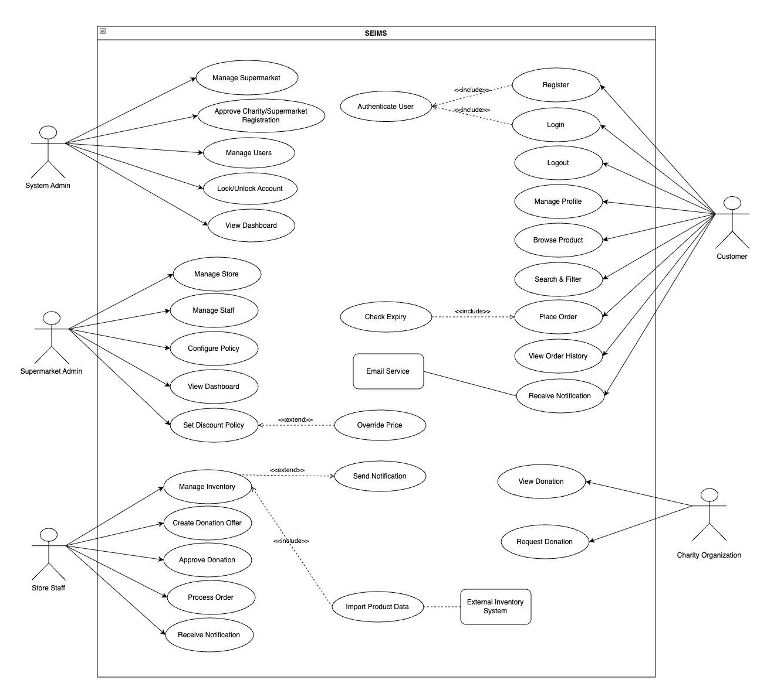

Figure 1. Use Case of “Smart Expiry Product Integration & Management System”

3. User Stories

3.1. Admin
Table 1. Use Case of “Smart Expiry Product Integration & Management System“ (Admin)
ID | As a/an | I want to | So that | Acceptance Criteria
US01 | Admin | See the home page | Explore all available services | Page loads < 3s; main navigation visible; no 404/500 errors.
US02 | Admin | Approve or reject supermarket registrations | Control which businesses join the system | Can approve/reject requests; status updated; notification sent; action logged.
US03 | Admin | Manage supermarkets | Maintain the system structure and partner list | Can add, edit, or disable supermarkets; data saved correctly to DB.
US04 | Admin | Manage user accounts | Ensure proper role-based access control (RBAC) | Can create, edit, or disable users; roles assigned correctly.
US05 | Admin | Lock or unlock user accounts | Restrict users who violate platform policies | Locked users cannot log in; status updated; action logged.
US06 | Admin | View the system dashboard | Monitor overall performance across all supermarkets | Shows total users, supermarkets, orders, and donations; loads < 3s.

3.2. Supermarket Admin
Table 2. Use Case of “Smart Expiry Product Integration & Management System“ (Supermarket Admin)
ID | As a/an | I want to | So that | Acceptance Criteria
US01 | Supermarket Admin | Manage stores | Organize and operate various retail branches | Can create, update, and manage specific store locations.
US02 | Supermarket Admin | Manage store staff | Coordinate personnel at each branch | Can create and manage staff accounts for specific stores.
US03 | Supermarket Admin | Configure near-expiry policies | Automate the detection of aging products | Can set expiry thresholds (e.g., 5 days); system flags products automatically.
US04 | Supermarket Admin | Set discount policies | Automate price reductions for near-expiry items | Discount rules applied automatically based on remaining days.
US05 | Supermarket Admin | Manually override prices | Have flexibility during special sales or conditions | Can manually adjust discount values; audit log records the change.
US06 | Supermarket Admin | View analytics reports | Make data-driven business decisions | Dashboard shows near-expiry trends, sales recovery, and waste metrics.

3.3. Store Staff
Table 4. Use Case of “Smart Expiry Product Integration & Management System“ (Store Staff)
ID | As a/an | I want to | So that | Acceptance Criteria
US01 | Store Staff | Create inventory lots | Track the lifecycle and expiry of product batches | Enter lot code, expiry date, and quantity; validation prevents past dates.
US02 | Store Staff | View near-expiry alerts | Take immediate action on products reaching thresholds | System notifies staff via in-app alerts when products are nearing expiry.
US03 | Store Staff | Create donation offers | Redistribute usable goods to charity organizations | Can select near-expiry lots to offer for donation; status updates to "Donated".
US04 | Store Staff | Process customer orders | Facilitate the in-store pickup process | Can view order details and update status (Pending, Ready, Completed).

3.4. Customer & Charity
Table 4. Use Case of “Smart Expiry Product Integration & Management System“ (Customer & Charity)
ID | As a/an | I want to | So that | Acceptance Criteria
US01 | Customer | Search and filter products | Quickly find discounted items by category or store | Search by keyword; filter by store, category, or discount rate.
US02 | Customer | Place an order | Secure near-expiry items before they sell out | Order confirmation recorded; prevents purchase of expired products.
US03 | Charity | Request donations | Receive usable products for community support | Can browse available donation offers and submit a request to the store.

4. Table User Stories Priority
Table 5. Table user story priority
User Story ID | User Story Name | Priority | Product Backlog ID
Admin
01 | Home page interface (Admin) | 2 | PB-01
02 | Approve/Reject Supermarket Registration | 1 | PB-02
03 | Supermarket Management | 1 | PB-03
04 | User Account Management | 1 | PB-04
05 | Lock/Unlock User Accounts | 1 | PB-05
06 | System Dashboard (Admin) | 1 | PB-06
07 | Personal Information Management | 2 | PB-07
Supermarket Admin
01 | Login/Logout | 1 | PB-08
02 | Store Management | 1 | PB-09
03 | Staff Management | 1 | PB-10
04 | Policy Configuration (Thresholds/Discounts) | 1 | PB-11
05 | Manual Price Override | 2 | PB-12
06 | View Supermarket Analytics | 1 | PB-13
Store Staff
01 | Create Inventory Lot | 1 | PB-14
02 | Near-Expiry Detection Alerts | 1 | PB-15
03 | Create Donation Offer | 2 | PB-16
04 | Order Management & Fulfillment | 1 | PB-17
Customer & Charity
01 | Search & Filter Near-Expiry Products | 2 | PB-18
02 | Place Order (B2C Marketplace) | 1 | PB-19
03 | View Order History | 2 | PB-20
04 | Browse & Request Donations (Charity) | 2 | PB-21
Development Team
01 | Near-Expiry Engine Development | 1 | PB-22
02 | API Integration (Excel/CSV/Simulated POS) | 1 | PB-23
03 | Notification System Integration | 1 | PB-24

